† HOW OLD IS THE CHRISTIAN ORTHODOX FAITH?
by Antonios Ramzi on Wednesday, December 22, 2010 at 2:58am
† HOW OLD IS THE CHRISTIAN ORTHODOX FAITH?
-------------------------------------------------------------------

† If you are a Lutheran, your religion was founded by Martin Luther, an ex-monk of the Roman Catholic Church-Germany, in the year 1517.

† If you belong to the Church of England, your religion was founded by King Henry VIII in the year 1534 because the Pope would not grant him a divorce with the right to remarry.

† If you are a Presbyterian, your religion was founded by John Knox in Scotland in the year 1560.

† If you are a Congregationalist, your religion was originated by Robert Brown in Holland in 1582.

† If you are a Protestant Episcopalian, your religion was an offshoot of the Church of England, founded by Samuel Seabury, in the American colonies in the 17th century.

† If you are a Baptist, you owe the tenets of religion to John Smyth, who launched it in Amsterdam in 1606.

† If you are of the Dutch Reformed Church, you recognize Michelis Jones as founder because he originated your religion in New York in 1628.

† If you are a Methodist, your religion was founded by John and Charles Wesley in England in 1774.

† If you are a Mormon (Latter Day Saints), Joseph Smith started your religion in Palmyra, New York in 1829.

† If you worship with the Salvation Army, your sect began with William Booth in London in 1865.

† If you are a Christian Scientist, you look to 1879 as the year in which your religion was founded by Mary Baker Eddy.

† If you belong to one of the religious sects known as “Church of the Nazarene”, “Pentecostal Gospel”, “Holiness Church,”, or “Jehovah’s Witnesses,” your religion is one of the hundreds of new sects founded by men within the past hundred years.

† If you are a Roman Catholic, your church shared the same rich apostolic and doctrinal heritage as the Orthodox Church for the first thousand years of its history since during the first millennium they were one and the same Church. Lamentably, in 1054, the Pope of Rome broke way from the other four Apostolic Sees (Patriarchates), by tampering with the original Creed of the Church, and considering himself to be the universal pastor over other Sees and infallible.

† If you are a Uniate Roman Catholic of any Eastern Rites, you had your roots in the Orthodox Church, but were forced into the Roman Catholic Church, either by financial hardship, or regional political/ ecclesiastical unrest (e.g.: Malankara Syrian Catholics), or by western colonialization (e.g.: Syro-Malabar Rite), or by military strength.

† If you are an Orthodox Christian, you religion was founded in the year 33 by Jesus Christ, the Son of God. It has not changed since that time. Our Church is now almost 2000 years old. And it is for this reason, that Orthodoxy, the Church of the Apostles and the Fathers is considered the true “One, Holy, Catholic, and Apostolic Church.”

† This is the greatest legacy we can pass on to the young people of the new millennium!

By Priest Dr. Miltiades Efthimiou.
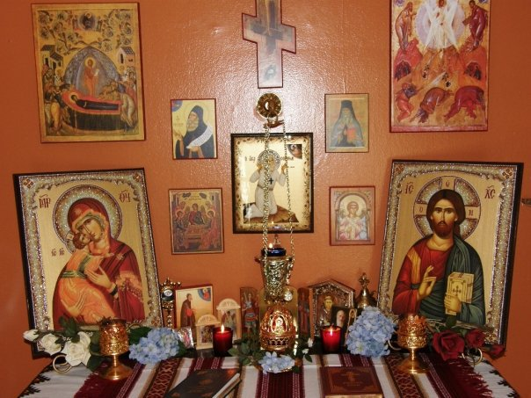

LikeUnlike · Comment · Share
- Lilian Eid and 4 others like this.

