Martyred Priest Daniel Sysoev & American Orthodox Missionary Work
via Koinonia by Fr Gregory Jensen on 10/1/10

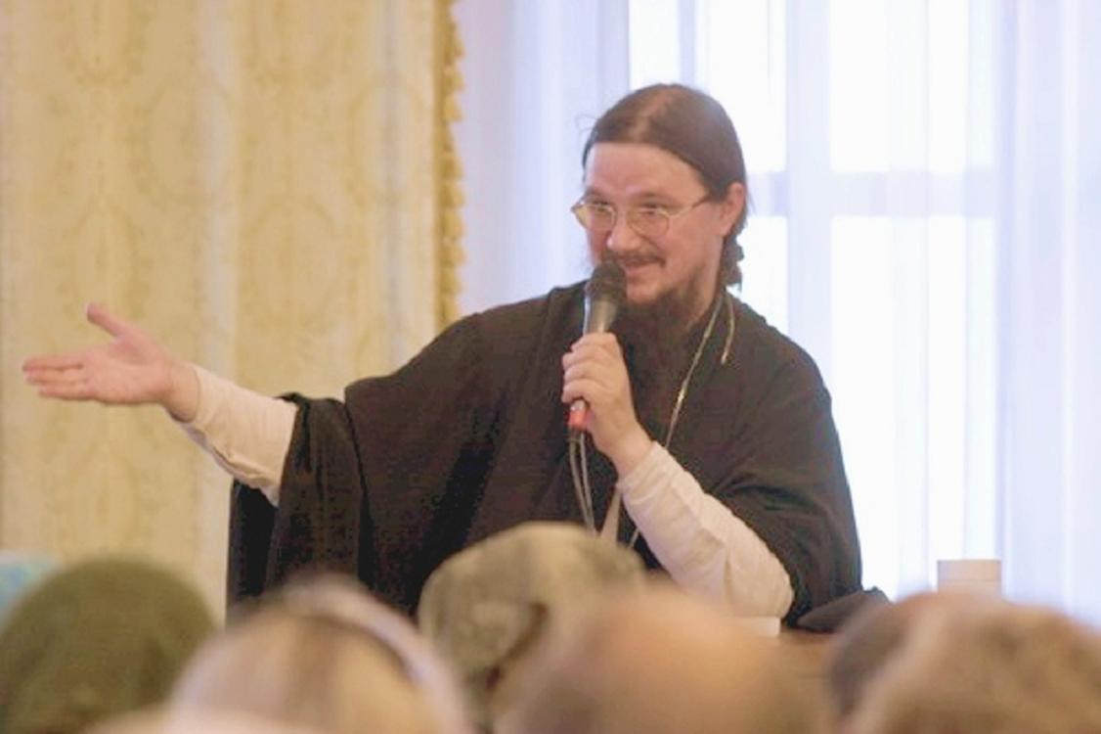For ORTHODOXY AND THE WORLD (www.pravmir.com), I was asked to write a reflection on the life, ministry and recent death of Fr Daniel Sysoev of Moscow. Specifically I was asked to respond to how “Fr. Daniel’s ideas would be useful and which may not be so effective in a typical North American or European parish, where people do not share the culture of Orthodox Christian nations, and are probably already Christian as opposed to Russia, where a missionary parish isn’t competing so much with other religious groups?” My response is below and will hopefully appear on ORTHODOXY AND THE WORLD soon.
In Christ,
+FrG
Missionary work by contemporary American Orthodox Christians is similar in many ways to that undertaken in Russia by the recently martyred Fr. Daniel Sysoev. Some of Fr Daniel’s practices–for example people gathering after Divine Liturgy to “drink tea or coffee together”–are the norm in American Orthodox parishes. Other things, like the daily recitation of the Psalms and the regular reading of Holy Scripture during the priest’s communion at Liturgy, are practices worth introducing here in America.
On the other hand Fr Daniel’s strong emphasis on religious education, especially catechesis and Bible study are rather unevenly practiced in America. Some of our parish have well developed religious education programs for children and adults, while other do nothing at all. The majority of our parish however limit religious education to catechetical classes for children. Unfortunately even these are often only poorly attended.
This is not to say that he situation in the States is bleak, it isn’t. But as Archpriest Andrew Phillips mentioned in his own essay (On Orthodox Pastoral Work in the Western World and its Differences with Contemporary Russia), the Church in America is small and poor. This is especially the case when we compare ourselves to the Roman Catholic Church or the various Protestant denominations. Many of our priests need secular employment to feed their families and so the life of the parish is largely limited to Saturday and Sunday (and sometimes only Sunday). Unfortunately because of this not only the pastoral life but also the missionary work of the Church suffers.
According to a recent survey, only about one third (34%) of Orthodox Christians in America attend church at least weekly. Sadly this is less than the national average of all religions (39%) and dramatically less than for Evangelical Christians (58%), members of historic black churches (59%), Catholics (42%), Jehovah Witnesses (82%) and Mormons (75%). At least in terms of weekly church attendance Orthodox Christians look more like mainline Protestants (also 34%). The only people less active on a weekly basis in their religious tradition are Jews (16%), Buddhist (17%), Hindus (24%), and the religious unaffiliated (5%).
Compare this to the fact that, according to the same survey that vast majority of Orthodox Christians say that religion (and here I am assuming this means the Orthodox faith) is very important (56%) or somewhat important (31%) in their lives. There first thing that should be apparent is the huge gap between the percentage of Orthodox Christians who say that their faith is important to them (87%) and the number of Orthodox Christians who attend Liturgy on at least a weekly basis (34%). Whatever else their faith might mean to them, it does not necessarily mean the regular participation in the liturgical life of the Church.
“Well what about converts?” you might ask, “Certainly, their dedicated, right?” Well, not really, or at least not as much as we might imagine.
For example, a slight majority of those who join the Orthodox Church as adults will leave. Calling these men and women “converts” seems to me to be a bit of a misnomer since those who join as adults are almost twice as likely to leave the Church as those baptized as infants- 54% of all adult “converts” members vs. 35% of all adult “cradle” members. For every 10 converts who leave, 6 cradle adults also leave, or if you prefer, for every one Greek or Russian Orthodox baptized as an infant who will leave the Church, 1.6 adult converts will also leave. Converts leave at a 60% greater number than cradle Orthodox adults.
Fr Daniel’s ministry offers us in American a solution. What is needed is clear, solid catechesis and effective spiritual formation for all, laity and clergy alike are essential. Catechesis, in sermons and religious education classes for children and adults, tells uswhat we believe. Spiritual formation tells us, or better yet, helps us, answer personally questions such as “Who am I in Christ?” and “What is Christ asking of me?” Spiritual formation is concerned with answer questions of personal identity and vocation. In other words, formation is about discipleship, about a personal, life-long commitment to Christ. While the tradition of the Orthodox Church is almost unbelievably rich, it seems to me that we seriously neglect the formation of our laity (and as a result, our clergy).
“But, Father,” you might ask, does this evangelism doesn’t matter? Shouldn’t we simply work to fill the Church with new, committed, Orthodox Christians?”
Given the ease with which Americans change religious affiliations making new members is not a challenge. The real challenge is retention; of actually keeping the members that we have by helping them become disciples of Christ. To borrow from St Ignatius of Antioch, it is not enough to be called a Christian, one must actually be a Christian. When many Orthodox Christians are Christian in name only, the Church’s witness to the Gospel is undermined. Whether we are looking at the experience of “cradle” or “convert,” this commitment is absent for many American Orthodox Christians. A credible witness is possible; we have the promise of Christ of this. But it requires from all of us a personal commitment to Christ. Again as Fr Daniel demonstrates, this means regular participation in the sacramental life of the Church (especially Holy Communion and Confession) and a willing eagerness of each of us to conform the whole of our life to Christ and the Gospel.
At a missions and evangelism conference in 2009, the primate of the Orthodox Church in America, His Beatitude Metropolitan Jonah said that “becoming Orthodox is not something that you can do just after 6 months of catechesis and a little bit of chrism on your forehead. It’s a life-long process, because it’s being transformed into Christ.” He continued by reminding his listeners that “coming into the Orthodox Church is not about joining a new organization; it’s not joining ‘the right church’; it’s not ‘joining the historical church or the apostolic church’; or it’s not ‘joining the right church instead the wrong church that I was in.’” Rather, and I think Fr Daniel would agree with this, becoming Orthodox is about entering ever “deeper into the mystery of Christ.” If we are not interested in becoming more like Christ we simply remain trapped “in our passions” and so “we might as well have not converted anyway, because we still haven’t left the world behind.”
Looking back at what I’ve written, I realize that much of it seems negative. My intent was not to criticize the Church in America but to reflect soberly on the challenges that we face and even the areas in which we have failed. Thinking about the life and death of Priest Daniel Sysoev this seems to me to be appropriate. The lesson I draw from Fr Daniel is that while the challenges are many, God’s grace abounds and it is only necessary for us, for me, to respond obediently to His will.
In Christ,
+Fr Gregory Jensen

